Q: What gets persisted to a database, classes or objects? Why is this needed?

Ans: The Object is persisted to a database. Object contains is the actual data as the class is just a blueprint.

Q: Explain the role of domain classes in an MVC architecture

Ans: The domain classes represent the persistent entity that is mapped to underlying database.

Q: what are the advantages of using an ORM instead of embedding SQL statements in the code?

Ans: The ORM takes care of the most of the manual configuration for database connection, including the creating database connection, Querying the database, and mapping the domain classes to database tables.

Q: would it be prudent to use the H2 database in a production setting? Why or why not?

Ans: No, it is not wise to use in-memory database in production. The in-memory database does not persist data when application is stopped. It is better to use some database which persists data, like SQL.

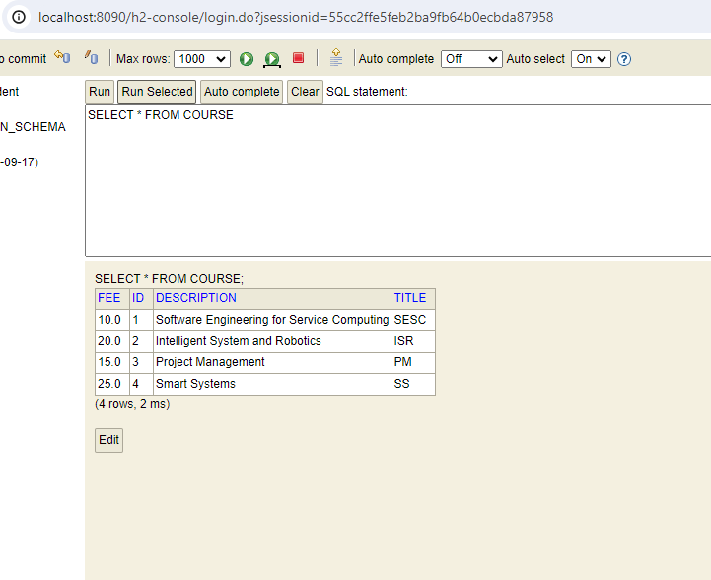

Figure : Database records

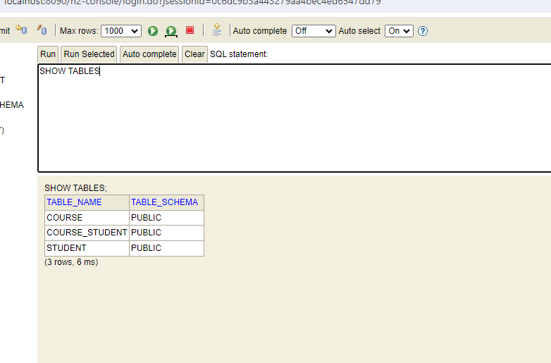

Figure : Tables

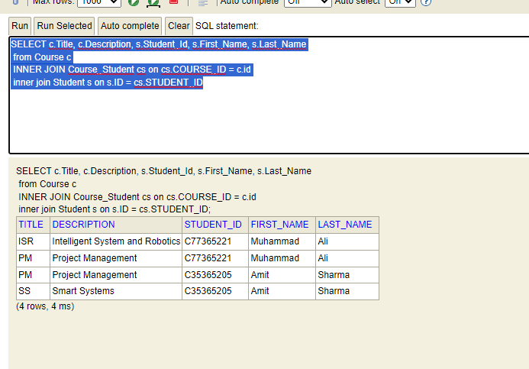

Figure : Table Data